Appendix – I

INFORMATION SHEET
No. | Name | Gender | Position | Passport No. | Clothing Size | Arrival/Return & Flight
1 |  |  |  |  |  | arrival:
 |  |  |  |  |  | departure:
2 |  |  |  |  |  | arrival:
 |  |  |  |  |  | departure:
3 |  |  |  |  |  | arrival:
 |  |  |  |  |  | departure:
4 |  |  |  |  |  | arrival:
 |  |  |  |  |  | departure:
5 |  |  |  |  |  | arrival:
 |  |  |  |  |  | departure:
6 |  |  |  |  |  | arrival:
 |  |  |  |  |  | departure:
7 |  |  |  |  |  | arrival:
 |  |  |  |  |  | departure:
8 |  |  |  |  |  | arrival:
 |  |  |  |  |  | departure:
9 |  |  |  |  |  | arrival:
 |  |  |  |  |  | departure:
10 |  |  |  |  |  | arrival:
 |  |  |  |  |  | departure:
11 |  |  |  |  |  | arrival:
 |  |  |  |  |  | departure:
12 |  |  |  |  |  | arrival:
 |  |  |  |  |  | departure:
Total number of rooms required:
 | Single Room |  |  | Twin Room
 | Name: |  |  | Email:
Remark:
 | - Please fill the in the sheets carefully and send it to IKCA email on or before September 28, 2020
 | - The option for the column of "Position" : Leader/ Coach/ Athlete/Officers/Others

Appendix – II

Visa information details

No | Name of Athletes | Gender | Position | Date of Birth | Passport Number | Passport Issue Date | Passport Expiry Date

Seal of the Association Signature :
Secretary General

Appendix III :

Format for Visa Request letter to Embassy: Please fill the details below marked in red:

Ref No. IKCA/Dragon Boat /Visa Date:

Embassy of India
<Please fill the complete and correct address>
<provide the email id>

Re: VISA CLEARANCE

Dear Sir,

This is to bring to your kind notice that Indian Kayaking & Canoeing Association is organizing the 2020 ICF Dragon Boat World Championships at Bilawali Talab (Lake), Indore (MP) India from November 12-15, 2020.

We humbly request your good self to kindly issue visa in the name of the following team members from <name of association & country>

Name of Athlete & Coaches <complete the details below>
No | Title | First Name | Last Name | Position | Date of Birth | Passport No. | Date of Issue | Date of Expiry
The above named participants have been invited to Bilawali Lake (MP) (India) for the said championship. The stay of the team has been arranged at the Hotel Sayaji, Hotel Mariott, Hotel Radisson, Hotel Effotel, Hotel WOW, Hotel Shreemaya, Hotel Pride, Hotel Surya, Hotel President.
Remark: The mentioned competition can be found in the calendar on the ICF website www.canoeicf.com .
Thank you for your attention and the consideration with issuing entry visa to Indore (India) for the named athletes and coaches.

Yours sincerely

(Prashant Kushwaha)
Secretary General
FOR ASSISTANCE/QUERY PLEASE CONTACT AS PER DETAILS GIVEN BELOW:

Mr. Dileep Singh Chauhan  Chairman of Dragon  Cell No: +91-9414165963 | Mr. M.S. Tomar  President, MPKCA  Cell No: +91-9425014243
Ms. Shilpa Vineet (event coordinator)
Shilpa_ikca2018@outlook.com
ikcasports@gmail.com
Mr. Prashant Kushwaha, Secretary General
Indian Kayaking & Canoeing Association
7- A/42 W.E.A. 2nd Floor, Western Chamber
Channa Market Karol Bagh
New Delhi - 110005
E Mail: ikcasports1@gmail.com

You are requested to kindly fill in the attached appendix and share the details at the earliest for our necessary action.
Looking forward to your participation.
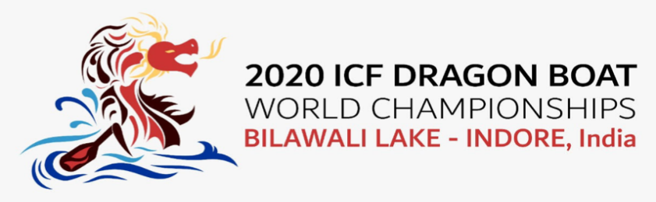

https://www.icfdbr2020.com
info@icfdbr2020.com | ikcasports@gmail.com

