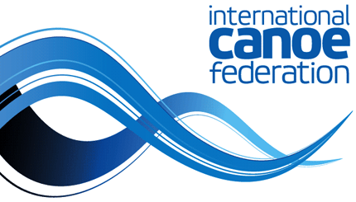
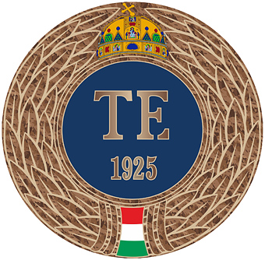

Canoe-Kayak Sprint Intensive Coaching Course Level 3

“Expert Coach”

APPLICATION FORM

April 1 – June 12, 2022

1. Name (first and family name):

2. National Federation:

3. Date of birth: ____/______/______ 4. Place of birth:
(Day/Month/Year)

5. Gender: female male 6. Tel.: +

7. Mobile: + 8. Religion:

9. E-mail address:

10. Address:

11. Passport number:

12. Citizenship: 13. Passport date of expiry:

14. Sport activities (competitor, coach) until the present:

15. Highest education level:

16. Nomination and stamp of the National Federation or relevant sport association of the applicant’s country:

17. My participation fee will be paid by: IOC NOC Government Private

National Sport Federation Sports Club

I hereby certify that all information provided by me in this application is accurate and complete.
I agree with each paragraph and statement of the information sheet.

date signature

Please send the duly (1) completed application form (filled in capital/block letters), a short (2) curriculum vitae, a (3) letter of recommendation by the National Federation and a (4) copy of your passport to the following e-mail address: kiss.gergely@tf.hu

